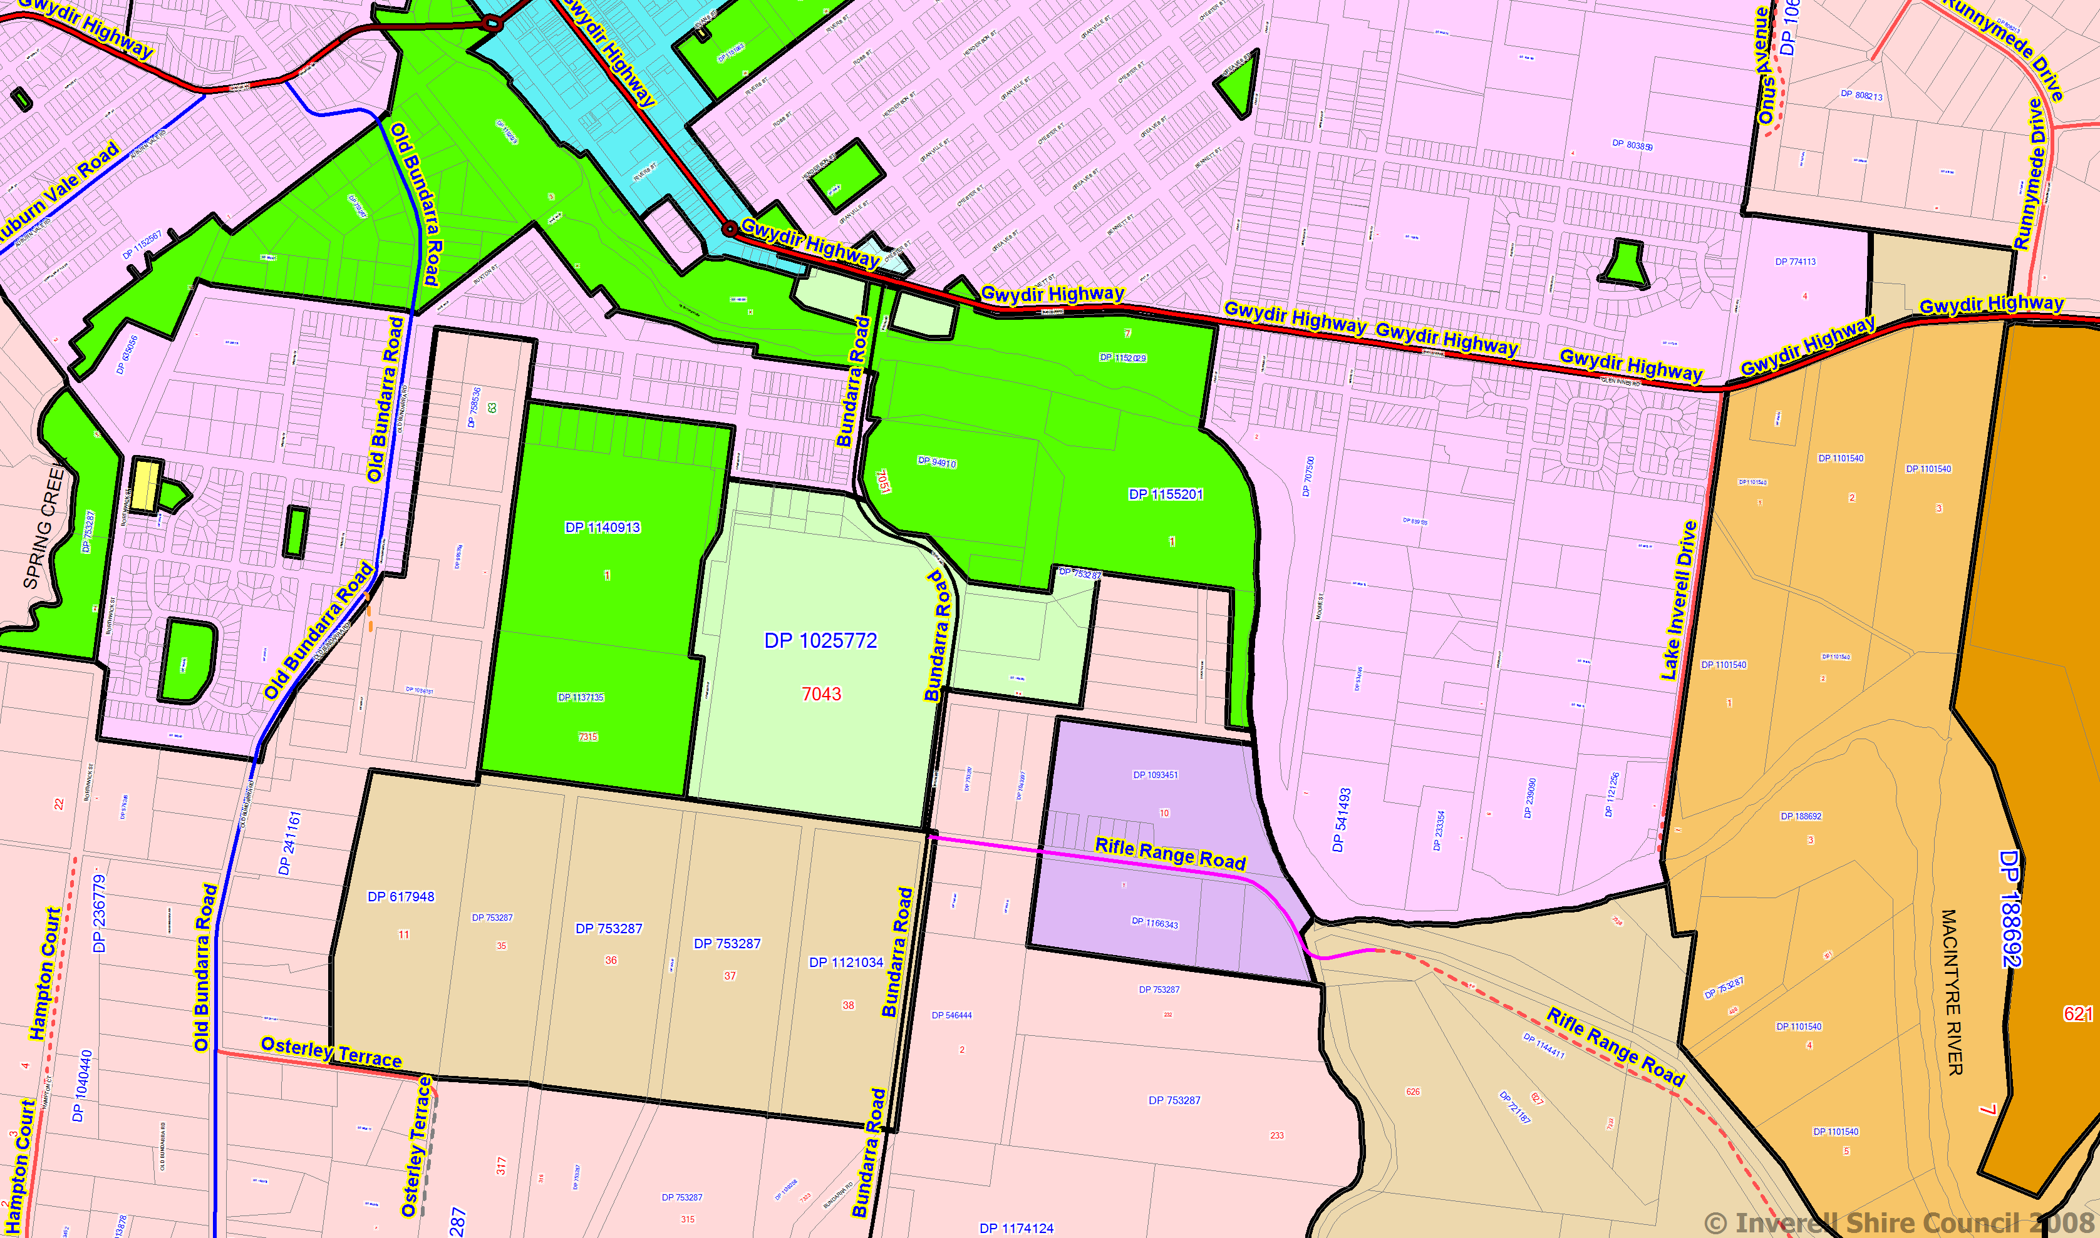
Primary Production
Rifle Range Rd.
General Industrial
Local Town Centre

